

Language, Literacy, and Culture Doctoral Program

Student Handbook

AY 2026 – 2027

Producing
Scholarship that Matters

University of Maryland, Baltimore County
1000 Hilltop Circle
Sherman Hall, Suite 202
Baltimore, MD 21250
(410) 455-2376
llc.umbc.edu

Table of Contents

Program Description and Contact Information 3

Program Advisement 4

Building a relationship with your Program Advisor 4

Expectations of Students with Regards to Advising 4

Communications 5

UMBC Resources 5
- The Graduate School and the College of Arts,
Humanities and Social Sciences 5
- Campus-wide Resources 6
Financial Assistance 6
- LLC Program Resources 6
- UMBC Offices for Billing and Financial Aid 7

Progression in the LLC Program 7
- General Coursework Terms and Information 7
- Timeframe for Degree Completion 8
- Completion of Course Requirements 8
- Specific Policies Relating to Coursework 9
- Comprehensive Field Examination 10
- Proposal Preparation and Defense 11
- Candidacy 11
- Dissertation Research and Defense 11

LLC Ph.D. Requirements at a Glance 12

Student Progression Diagram 13

Planning your Path to Degree Completion 14

LLC Progression Worksheet 15

Important Links:

Student Instructions for the Comprehensive Field Examination
Protocols and Guidance Concerning the Dissertation Process

Program Description and Contact Information
Founded in 1998, the LLC Program celebrated its 25th anniversary in 2023-2024. This interdisciplinary doctoral program investigates the concepts and processes of language, literacy, and culture in relationship to social, cultural, linguistic, historical, technological, and ideological formations. We advocate for socio-cultural and linguistic diversity in research, practice, and policy, with special emphasis on social justice, change, equity, power, and identity.

Our research and teaching community includes affiliated faculty from more than nine departments across our campus. The alliances made with other academic departments at UMBC have made our program an ideal incubator of knowledge and interdisciplinary inquiry.

The participating departments in our program are Africana Studies; American Studies; Education; English; Gender, Women’s, and Sexuality Studies; History; Media and Communication Studies; Modern Languages, Linguistics, and Intercultural Communication; and Sociology, Anthropology, and Public Health.

There are approximately 60 affiliate faculty members from UMBC departments outside of LLC who work with LLC doctoral students by serving on dissertation committees or teaching relevant coursework. LLC students are encouraged to review the list and become acquainted with these scholars.

LLC’s Core faculty for the AY 2026-2027 year include:

- Ramon Goings, Professor and Program Director, rgoings@umbc.edu
- Christine Mallinson, Professor and Assistant Vice President for Research and Scholarship, mallinson@umbc.edu
- Nicole Morse, Associate Professor, nemorse6@umbc.edu
- Christa Porter, Associate Professor, and Vice Provost and Dean of the Graduate School, cporter1@umbc.edu
- Craig Saper, Professor, csaper@umbc.edu
- Tanya Saunders, Professor, tanyasau@umbc.edu
- Christia Spears Brown, Dean of the College of Arts, Humanities, and Social Sciences (CAHSS), csbrown@umbc.edu

The program’s Coordinator is Catherine Myers, catmyers@umbc.edu, (410) 455-2376.

As of August 2026, 156 students have earned an LLC Ph.D. since its inception in 1998. LLC students have come from a variety of backgrounds and countries, promoting a meaningful dialog and vibrant community. More than half of our graduates are employed at a college or university. Other alumni work in K-12 schools or school systems, government agencies, NGOs, and a smaller number in industry or consulting.

Program Advisement

Each LLC student is assigned a program advisor after they matriculate in the program. These advisors are always Language, Literacy & Culture faculty members and should be differentiated from a dissertation advisor or mentor, who is selected by the student around the time they begin planning for their Comprehensive Exam. (On occasion, the program advisor and dissertation advisor are the same person.)

A. Building a relationship with your Program Advisor

The most fundamental responsibility of your program advisor is to help students with course selection and progression advisement each semester. However, program advisors also provide the following support:

- Discussing your evolving research ideas

- Helping to identify multiple mentors at UMBC and beyond who can support your research, professional development, and personal growth

- Discussing your long-term professional goals and how your research focus and mentors might be related to professional aspirations

- Sharing information on professional development and intellectual growth opportunities on campus and beyond

- Offering guidance and support letters for funding and fellowship opportunities at UMBC and beyond

- Listening to your concerns and helping you navigate resources at UMBC for counseling, etc., as needed

B. Expectations of Students with Regards to Advising

Every semester it is the student’s responsibility to meet with their program advisor to discuss the courses they are interested in taking in the upcoming semester. After completing LLC 890, the last seminar course for students, it is the student’s responsibility for navigating their progression by utilizing the Progression Worksheet found in their student Box folder. The student is still required to check-in with their program advisor semi-annually for programmatic guidance. For optimal advisement, the student should articulate their research goals more specifically over time and outline their tentative timeline for program completion.

To foster a productive relationship, students should:

- Be responsive and communicative with their program advisor

- Prepare for semi-annual advising by first reviewing course options for the upcoming semester and updating their Progress Report and uploading it to their student Box folder

- Wait to register for classes until after they meet with their program advisor

C. Communications

Students should use their umbc.edu email address for all correspondence. Practicing good email etiquette of reading and responding to emails in a timely, respectful manner is vital for student success.

Students are automatically added to the LLC myUMBC Group and to LLC’s google group, both of which will generate emails to their inbox.

Students can also follow LLC’s LinkedIn account at https://www.linkedin.com/in/llcphd/

UMBC Resources

The Graduate School and the College of Arts, Humanities, and Social Sciences

The Language, Literacy, and Culture Doctoral Program operates under the rules and policies of the UMBC Graduate School, though its funding and academic home is within the College of Arts, Humanities, and Social Sciences (CAHSS). Both of these entities provide a variety of resources important to our program and its students such as:

Graduate School resources:
- Graduate School Policies
- Graduate Student Association
- Office of Grad Student and Postdoc Development

CAHSS resources:
- Dresher Center for the Humanities
- Center for Social Science Scholarship

Campus-wide Resources

Albin O. Kuhn Library & Gallery offers research help specifically to graduate students, a variety of study spaces, lockers and specialty rooms, and an extensive collection of books, videos, articles, and more.

Institutional Review Board (IRB) is responsible for protecting the rights and ensuring the safety of human subjects participating in research. The IRB requires that all investigators who are affiliated with UMBC and who are engaged in research, regardless of funding, comply with both UMBC procedures and federal regulations regarding the protection of human subjects in protocol activities.

Office of Equity and Civil Rights (ECR) manages UMBC’s efforts related to civil rights issues. It has a confidential online reporting/referral system to report sexual misconduct, discrimination, or bias.

Office of Student Disability Services (SDS) coordinates accommodations for UMBC students with documented disabilities, as well as those with temporarily disabling conditions and injuries, which may require accommodations.

Retriever Integrated Health provides health services and free counseling services to support students’ well-being.

Financial Assistance

LLC Program Resources

Graduate Assistantships

Each year the LLC Program awards a limited number of graduate assistantships (GAs) to continuing and new graduate students in the program. Our assistantships are generally academic-year appointments to assist with research or teaching in one of our nine partnering departments, or with LLC core faculty. (This means that there is no tuition or stipend offered during the summer, though health insurance coverage extends through mid-August.)

The assistantship provides graduate students with a modest stipend paid biweekly, a tuition and fee waiver of up to 9 credits per semester, and health insurance coverage. In return, students are required to work with the assigned department and/or faculty member for a maximum of 20 hours per week. Part-time assistantships are available, as well, for a maximum 10 hours of work per week. These assistantships provide a half-stipend, offer a tuition and fee waiver of up to 6 credits per semester, and provide health insurance coverage.

Generally, LLC can provide an assistantship for up to four years, with a possible fifth year of support in exceptional circumstances, though the assignments may change between years. Only those students who are making sufficient academic progress and satisfactorily completing their GA tasks and responsibilities will be eligible for continued support of this nature.

Tuition Assistance

LLC recognizes that some of its students will be completing their Ph.D. while working full-time. Some of these students may not have employment benefits that adequately cover the cost of graduate tuition. In these cases, LLC may be able to provide limited tuition waivers on a case-by-case basis. Go to https://llc.umbc.edu/llcforms/ to complete a Tuition Assistance Eligibility Form if you wish to be considered for this type of support.

Student Research and Travel Awards

Students who plan to attend or present a paper at a conference or who have dissertation research expenses are encouraged to apply for funding through both the Graduate Student Association and the LLC Program. An application form can be found on the LLC website at https://llc.umbc.edu/llcforms/.

UMBC Offices for Billing and Financial Aid

The Financial Aid and Scholarships Office assigns counselors based on a student’s last name who can answer questions about financial aid options such as grants and loans and payment plans.

The Student Business Services Office handles student billing and payments. It also lists the latest tuition/fee rates.

Progression in the LLC Program

General Coursework Terms and Information

All LLC courses require course permission. After a student meets with their program advisor, the student should email the Program Coordinator (and copy their advisor) with the courses they plan to take the following semester. Permissions for LLC courses will be handled by the Coordinator and students will get an automated email informing them that they are ready to register.

Course credit hours refer to credits earned for taking and passing classes. At UMBC, a graduate student can take 600 (master’s level), 700 (doctoral level), or 800 (independent and research) courses to earn course credit hours. All courses must have a letter grade to count towards Ph.D. progression with the exception of LLC 890, LLC 898 and LLC 899 that are graded satisfactory or unsatisfactory.

Independent study courses refer to an individualized course of study that a graduate student pursues, designs, and completes within a semester under the guidance of a graduate faculty member who has agreed to direct it. These courses are numbered LLC 892 and are generally worth 3 credit hours for a letter grade. We ask that graduate students understand that an independent study may or may not be acceptable depending on the faculty member’s workload and preference. All Independent study courses must include a syllabus with the doctoral level work highlighted for either type of IND course (whether connected to an existing course or a new course).

Dissertation research hours refer to credits earned for independent work on one’s dissertation. These hours are taken under the 9-credit course LLC 899. All students must take two semesters of LLC 899. Students are eligible to take this course after they achieve candidacy. The credits are taken for a satisfactory/ unsatisfactory grade.

Timeframe for Degree Completion

The Graduate School allows Ph.D. students up to five years (10 semesters) to complete all required coursework, successfully defend their research proposal, and achieve candidacy. After candidacy, students have an additional four years (8 semesters) to complete their research and defend their dissertation. If a student is unable to complete either stage of their progression within this time frame due to extenuating circumstances, they will need to formally request an extension through the Graduate School. Students need their program advisor’s approval to take this action.

Completion of Course Requirements

Introductory Required Courses

These four courses (worth a total of 12 credit hours) are typically taken within the first year so that students track with their cohort. These courses are colloquially called “core courses” and refer to a set of courses LLC students must take at the start of their course progression to fulfill their degree requirements. The core courses provide an understanding of the role of interdisciplinarity and scholarship that covers both humanities and social science disciplines. The similarities and differences in research theories, methods, and writing practices are covered in these core courses.

LLC 700 Introduction to Language, Literacy, and Culture I
LLC 701 Introduction to Language, Literacy, and Culture II
LLC 744 Methods of LLC Research I
LLC 745 Methods of LLC Research II

Specialization Courses

Four or five specialization courses are required to meet the graduation requirement for a combined total of 7 specialization and methodology courses. Students can choose from LLC’s specialization courses and the courses offered by its partnering departments and others. All coursework selections should be reviewed and approved by a student’s program advisor before registration.

Research Methodology Courses

Two or three additional courses (beyond our core methodology courses) are required to meet the graduation requirement for a combined total of 7 specialization and methodology courses. Students can choose from LLC’s methodology courses and the courses offered by its partnering departments and others. All coursework selections should be reviewed and approved by a student’s program advisor before registration.

D. Specific Policies relating to Coursework

- Students must have access to a computer capable of accessing the internet and video-based and file sharing tools, a camera and sound, as well as word processing software (at a minimum) to successfully complete digital assignments and a dissertation. Camera use is preferred but not required for online classes.

- All students are required to update their personal Progression Report each semester. Each LLC student has their own Box Folder that is created and shared with them in their first semester.

- UMBC graduate students must maintain an overall B average or may be placed on academic probation that could result in academic dismissal.

- Students with two incompletes in ANY courses are barred from taking new courses without first meeting with faculty and presenting a completion plan.

- Students are allowed to take courses outside of UMBC if it makes sense academically and does not duplicate the LLC Program’s course offerings. Students must gain approval from their program advisor in advance of taking any such course.

- While Independent Study (IS) courses are not optimal, the LLC Program recognizes that they may sometimes make sense for a student’s progression. There are two types of IS courses (both using the course number LLC 892):

  - undergraduate lecture (“contract”) course whose syllabus has been augmented for doctoral students (student should initiate a discussion with the instructor to modify the course).

  - one-on-one independent study course with a UMBC faculty member with expertise in an area not covered by a lecture course (offered within the confines of the student’s progression needs). A specialized syllabus will need to be created that includes learning outcomes and course expectations.

It is up to the discretion of the student’s program advisor how many IS courses can be taken after the four required courses in the program have been completed. However, the first type is preferred. Students anticipating the need for an IS course should discuss this option with their Program Advisor before contacting a potential instructor. This process should be initiated well in advance of the start of the desired semester, with at least six weeks’ advance notice for a course in the second category, as there are more steps involved.

- Students may petition for up to two courses taken prior to matriculation in the LLC Program to be allowed to count towards their specialization/methodology coursework requirements. The decision to count them will not be made until a student has chosen their area of research and has completed the four introductory courses. (Students will need to supply a transcript and syllabus for each course, as well as describe its relevance to their research.) These courses must have been completed within five years of matriculation in the program with a grade of B or better. The courses cannot have counted towards a previous degree.

Comprehensive Field Examination

Taking the Comprehensive Field Examination is a required, standardized process that all LLC students must complete. Students are permitted to begin their Comps after completing the required 33 credit hours of coursework. As part of program advisement, a student’s LLC Program Advisor determines eligibility to initiate the process.

Purpose of the Comprehensive Field Examination

The Comps compel students to integrate information they have learned throughout their time in the LLC Program into two substantive papers that extend their scope of inquiry in ways that directly connect to their envisioned dissertation project. In other words, the culmination of the Comps process should yield two solid scholarly papers that are designed to directly inform their prospective dissertation.

The examination takes approximately one semester to complete and during that time students register for two to three sections of LLC 898 Pre-Candidacy Doctoral Research (worth 3 credits but billed at 1). In addition, students may take LLC 898 while preparing for their comps, and again after, or at the same time as, LLC 890, but before achieving candidacy.

Please see the Student Instructions on LLC’s website for a detailed description.

Comprehensive Exam Timeline
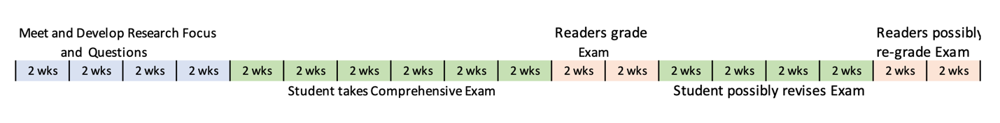

Proposal Preparation and Defense

Students who have successfully completed their comprehensive examination are required to take LLC 890 Research Proposal Seminar to prepare for their dissertation proposal defense. This oral defense is accompanied by a written dissertation proposal, whose content varies based on the area of study a student is pursuing.

Students may defend their dissertation research proposal at the completion of LLC 890 or in a subsequent semester. Before scheduling a proposal defense, students must have finalized their research proposal and formed a dissertation committee. The LLC Director must approve the composition of each dissertation committee prior to a proposal defense.

Candidacy

After successfully completing their proposal defense, a student should apply for candidacy with the Graduate School. Once a candidate, a student is eligible to register for LLC 899 Dissertation Research (worth 9 credits but billed at 2). Students must take a minimum of two semesters of LLC 899 in order to graduate.

Dissertation Research and Defense

Ph.D. candidates are allowed four years (8 semesters) to complete their research, write their dissertation, and successfully defend it, at which time they can graduate.

The Protocols and Guidance Concerning the Dissertation Process in the Language, Literacy & Culture Doctoral Program offers a detailed description of a student’s progression after the Comprehensive Field Exam. It is a valuable resource for both students and committee chairs and can be accessed here.

LLC Ph.D. Requirements at a Glance

4 Introductory required courses 12 credits
4 or 5 Elective Specialization courses 15
2 or 3 Elective Methodology course 6
1 LLC 898 Comprehensive Exam 3
1 LLC 890 Proposal Prep/Defense 3
2 LLC 899 Dissertation research 18
Total credits 57 *

*Minimum number of credits needed to graduate. Some students will take more of the 800 level courses or choose to take additional electives.

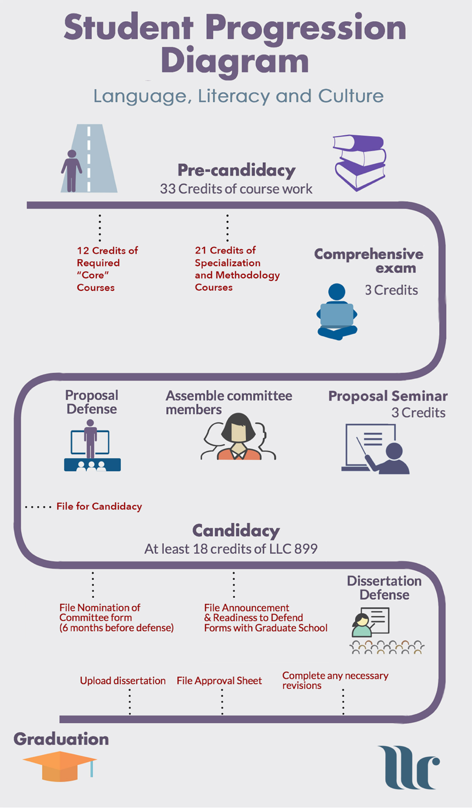

Planning your Path to Degree Completion

Pursuing your own Path
Each student’s journey is personal and unique. Along the way, each must contend with a variety of factors that can hinder their progress. Take the time to plan and set goals, but if you get thrown off track, be kind to yourself and use the resources available to help you, including the Program’s faculty and staff who want you to succeed. Below are two timeline scenarios to get you started:

4-Year Plan

Year 1 Fall: 2 Core Courses
Spring: 2 Core Courses and 1 Elective Course

Year 2 Fall: 3 Elective Courses
Spring: 3 Elective Courses

Year 3 Fall: Comprehensive Exam
Spring: LLC 890 and Proposal Defense

Year 4 Fall: Dissertation Research
Spring: Dissertation Research and Dissertation Defense

5-1/2-Year Plan

Year 1 Fall: 2 Core Courses
Spring: 2 Core Courses and 1 Elective Course

Year 2 Fall: 2 Elective Courses
Spring: 3 Elective Courses

Year 3 Fall: 1 Elective Course and Comps prep
Spring: Comprehensive Exam

Year 4 Fall: LLC 890
Spring: Proposal Defense

Year 5 Fall: Dissertation Research
Spring: Dissertation Research

Year 6 Fall: Dissertation Research and Dissertation Defense

While the Student Progression Report (discussed under Advising) is a detailed record of what a student has accomplished to date, the worksheet below may be a useful tool to help you plan your overall Ph.D. journey.

LLC Progression Worksheet

Student: Cohort:

Coursework | Projected Semester and Year | P | Notes
LLC 700
LLC 701
LLC 744
LLC 745
Elective Course 1
Elective Course 2
Elective Course 3
Elective Course 4
Elective Course 5
Elective Course 6
Elective Course 7
*LLC 898: Comps prep
LLC 898 Comps exam
LLC 890
*LLC 898 Proposal prep/defense
LLC 899 Dissertation research
LLC 899 Dissertation research/defense
*LLC 899 Dissertation research/defense
*LLC 898 and LLC 899 are repeatable. A minimum of two LLC 899s is required.

